Regulations:
A18

H.T No

Sreenidhi Institute of Science and Technology
(An Autonomous Institution)
Code No: 7AC02 Date: 18-June-2019 (FN)

B.Tech I-Year II-Semester External Examination, June-2019 (Regular)
NETWORK ANALYSIS (ECM)

Time: 3 Hours Max.Marks:70

Note: a) No additional answer sheets will be provided.
b) All sub-parts of a question must be answered at one place only, otherwise it will not be valued.
c) Missing data can be assumed suitably.

Part - A Max.Marks:20

Answer all QUESTIONS.

1. | State Kirchhoff’s voltage law and Kirchhoff’s current law. | [2M]
2. | Define the Quality factor and bandwidth of a circuit. | [2M]
3. | Explain the term coefficient of coupling in magnetic circuits. | [2M]
4. | State Thevenin’s theorem and specify the types of network to which it is applicable. | [2M]
5. | Define Z and Y-parameters of a typical four terminal network. | [2M]
6. | Define the term Time constant of a RC circuit. | [2M]
7. | A sine wave has a peak value of 12V. Determine RMS value and form factor. | [2M]
8. | Define the terms Flux Density (B), Magneto-Motive force(MMF) and field strength. | [2M]
9. | Draw the transient response of RL series circuit with DC excitation. | [2M]
10. | Write the relationship between Z, Y, h and ABCD parameters. | [2M]
Part – B Max.Marks:50
ANSWER ANY FIVE QUESTIONS. EACH QUESTION CARRIES 10 MARKS.

11. | a) | Explain the concept of super mesh and super node. | [5M]
 | b) | Obtain the delta connected equivalent for the star connected circuit shown below where R_{a}=8Ω, R_{c}=5Ω and R_{b}=15Ω.  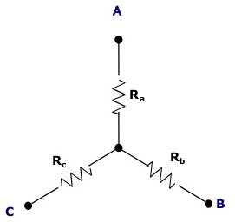 | [5M]
12. | a) | Find the resonance frequency for series resonant circuit and draw the reactance curve. | [6M]
 | b) | Discuss the practical applications of quality (Q) factor. | [4M]
13. | a) | State Faraday’s law of electromagnetic induction. | [4M]
 | b) | Calculate the mmf required to produce a flux of 5mWb across an air gap of 2.5mm of length having an effective area of 100cm² of a cast steel ring of mean iron path of 0.5m and cross sectional area of 150cm².The relative permeability of the cast steel is 800. Neglect leakage flux. | [6M]
14. | a) | State and prove Reciprocity theorem and Milliman’s Theorem. | [5M]
 | b) | In the circuit shown below determine the value of the load resistance when the load resistance draws maximum power. Also find the value of maximum power.  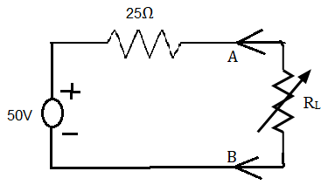 | [5M]
15. | a) | Explain the concept of Two port network. | [6M]
 | b) | For a Two port network, Y parameters are y₁₁=0.1Ω, y₂₂=0.05Ω, y₁₂=y₂₁=-0.02Ω, calculate the Z-parameters of the network. | [4M]
16. |  | Explain the terms critical resistances, damping ratio and frequency as applied to the study of RLC series circuit. How they help in simplifying the analysis of the circuit? | [10M]
17. | a) | Explain the concept of parallel magnetic circuit behavior. | [6M]
 | b) | Write short note on:  (i) Source transformation (ii) mesh and node analysis | [4M]
18. |  | What do you understand by a reciprocal network? How will you find out the π-equivalent of a given network when its Y-parameters are known? | [10M]

-- 00 -- 00 –

